**Lab Assignment 9**

This web application designed using node js when the server runs in the local host and we run the web application on the server. This is a Mash up of two web services one is face detection and the other is Tone analyzer.

**Wire Frames:**

**Home Page:**

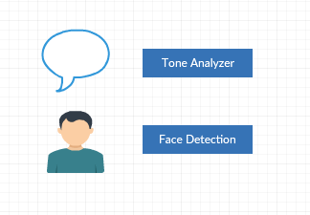

**Tone Analyzer Page:**

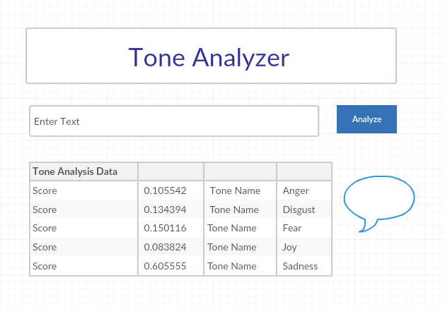

**Face Detection Page:**

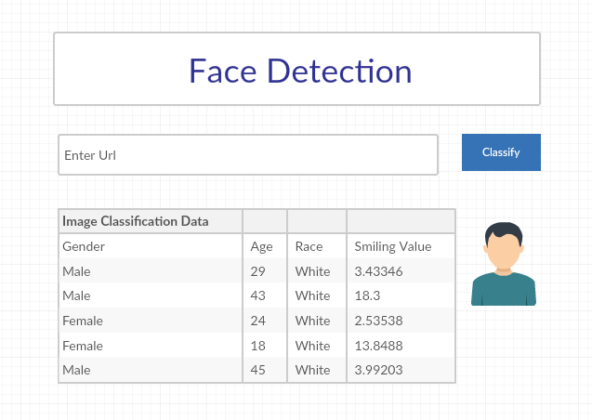

**Web Application Pages:**

**Home Page:**

This is the Home Page of the application where we have two buttons to navigate in to two pages which are Tone Analyzer and Face Detection.

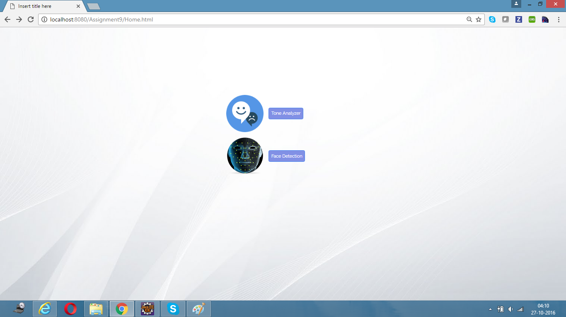

**Tone Analyzer Page:**

This is tone analysis page when you enter text in the test field which is then analyzed using IBM Watson Tone Analyzer API and gives the analysis data in the form of JSON file which is read in the client side and displayed in tabular format in the web application.

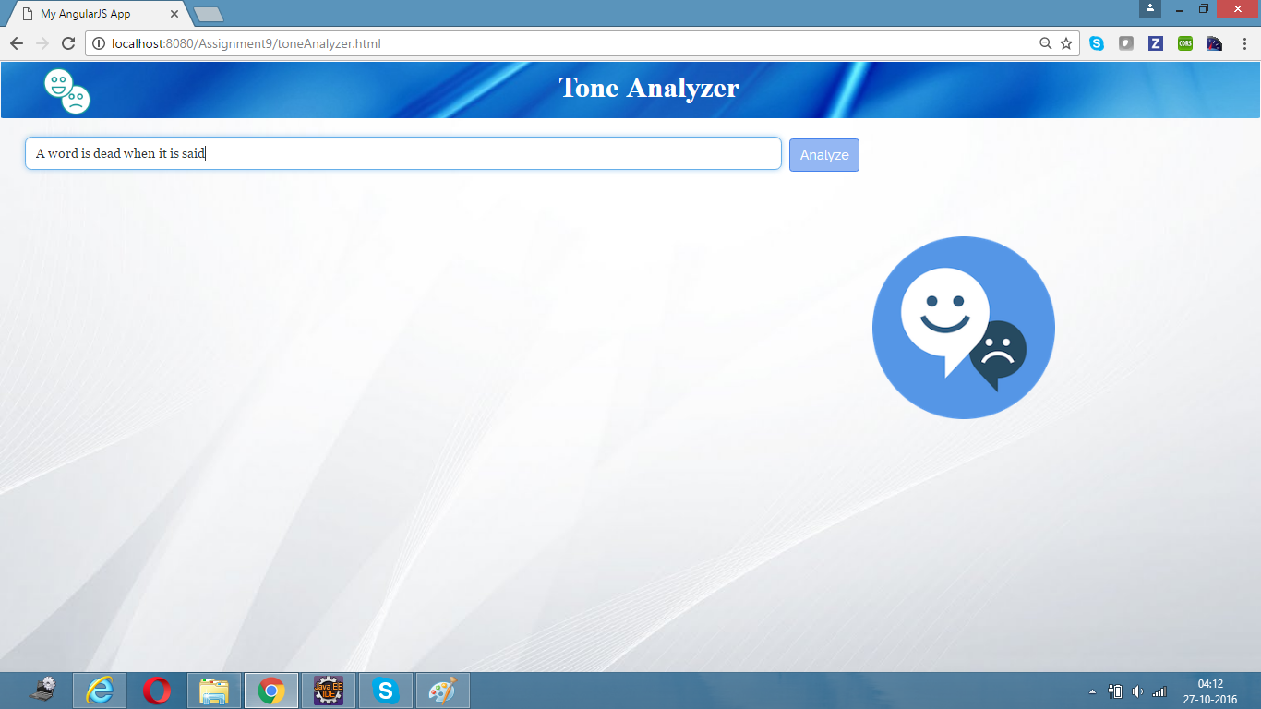

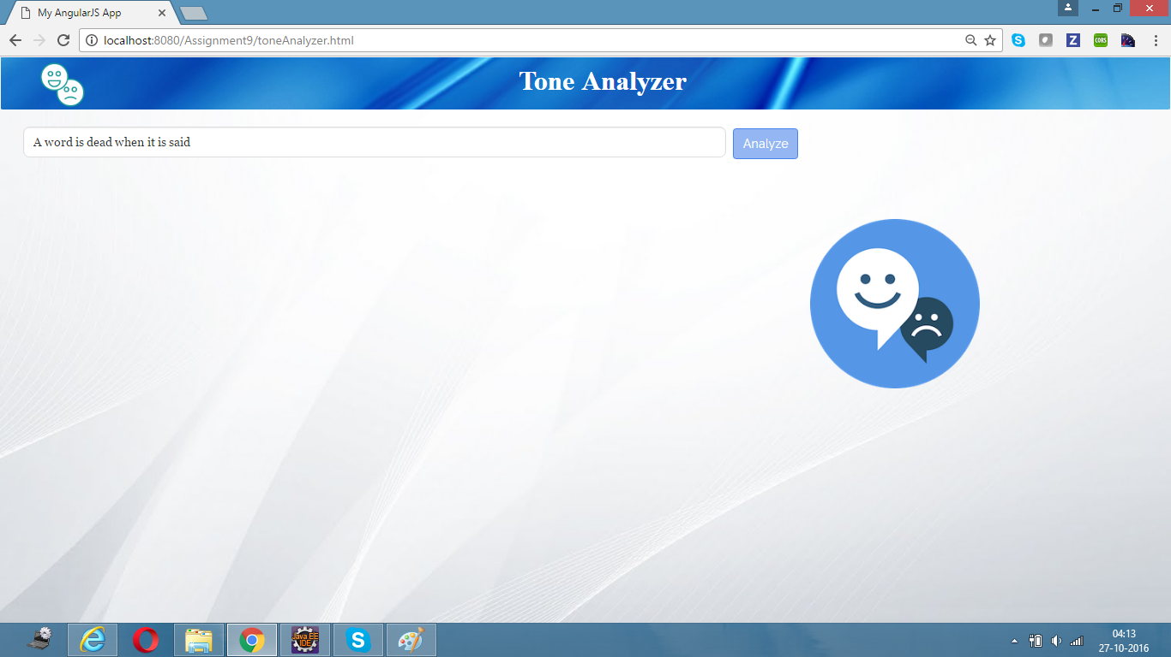

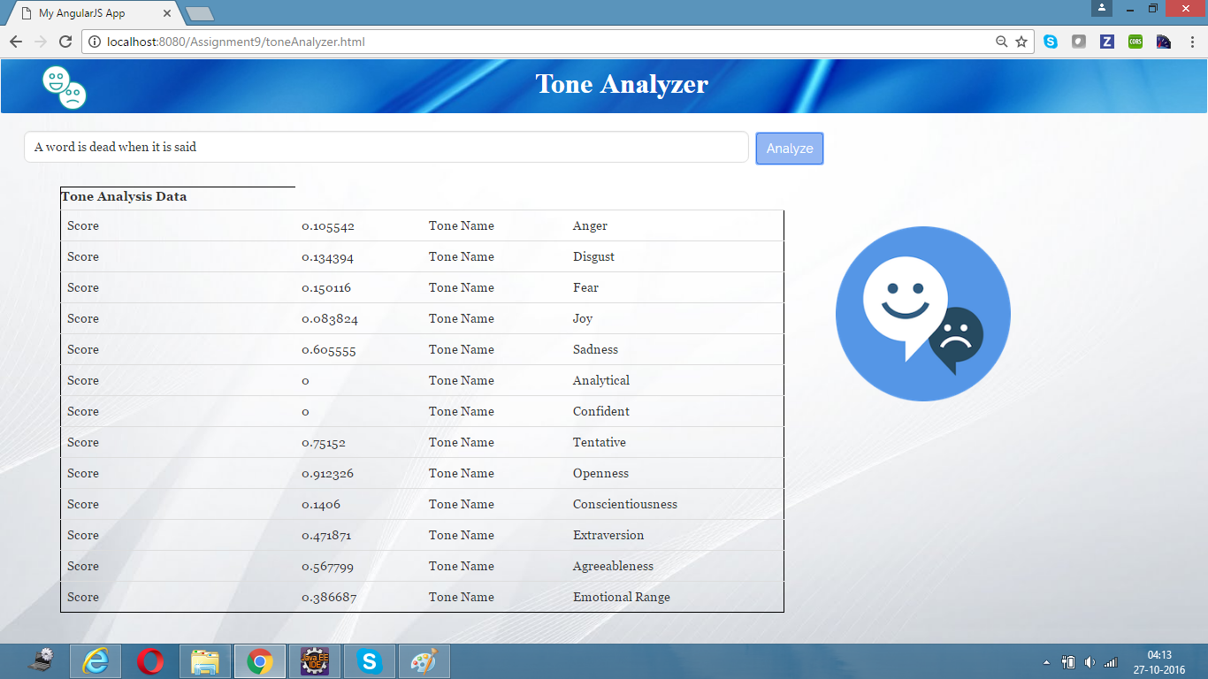

**Face Detection Page:**

This is the face detection page where you enter the url of the image containing persons. It analyzes the number of persons, their age etc using Face ++ API and generate the output in the form of JSON which is then converted into table.

